**COS 30017**

**EXTENSION ON MOBILE UX PATTERNS**



Student name: Bill Pham

Student ID: 103826322

# Introduction

# In this report, I will provide the following apps: Weather, AppStore, TV, Uber and Facebook. From these app, I will talk about the three UI design that I found across these app. Meanwhile, I will point out the advantage and disadvantage of the UI design pattern that these app using. Moreover, for each app, UX design pattern based on three criteria: structure, hierarchy, and incentivization for each app also being decompressed in this report

# Card design UI pattern

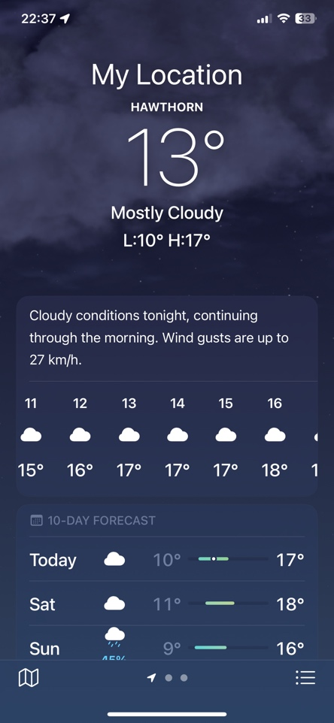

Figure 1 Weather app and app store

The weather app and the app store contain multiple type of information. Such as the weather app need to show the weather like, the temperature, etc which all separate information but still fall into same topic. Meanwhile, the AppStore need to show a while range of app for the user. So the card is being used which first make the app have a good visual design, second, the card is showing the collection of an app with multiple data such as image, name, etc…

**Advantage:**

The card UI design is look similar to real world tangible cards as they appear on the interface of the design. This design idea is adapted to the unique characteristics of each programme, including the weather app and the App Store. Each card serves to present separate content that supports the app's overarching concept, and it is flexible enough to display a variety of information while keeping the app cohesive. For instance, these cards efficiently convey weather forecasts in the weather app, while in the App Store they act as marketing tactics to encourage users to download particular applications. According to the underlying idea of app promotion and user engagement, each card in the App Store features various applications.

**Disadvantage:**

A significant drawback of using cards in UI design is navigating through complex structures. While cards excel at presenting concise information, relying extensively on a multitude of cards for navigation purposes can result in a confusing and cumbersome user experience.

As the nature of the card to display a small information, there will come into issue. Generally, the user cannot determine what is the priorities that require user attention toward that information. For the two application above, this disadvantage seem not to be the big problem of the UI design. Especially for the weather app, the main information that the user want to know is already appear in the top of the screen. The card in that application act like a contributed information so it will not affect the user UX.

**UX design analysis:**

1. **Content structuring:**

For the app store, the card contains the picture represent the application and the name, The goal of content structuring is to minimize the friction which is archived. The user can navigate thought a new app quickly and seamlessly.

1. **Hierarchy:**

For the card design, the name of an app must be big and catch attention from the user. The Appstore have archive it (figure 3). Meanwhile. In the weather app, the information inside the card also follows a hierarchy structure, priorities the information that expected to see from the user to be bigger. Such as the user want to know what the weather temperature is like for Saturday then, their attention will be catch immediately by this and the temperature of that day.

Figure 2 Weather app component

1. **Incentivization:**

The app store is the app that archive this one the best by having a download button beside the name of the apps. This design encourages the user to download it right away if the poster of that game which display above attract them which out any further navigation.

Figure 3 App Store card

# Picture carousel UI pattern

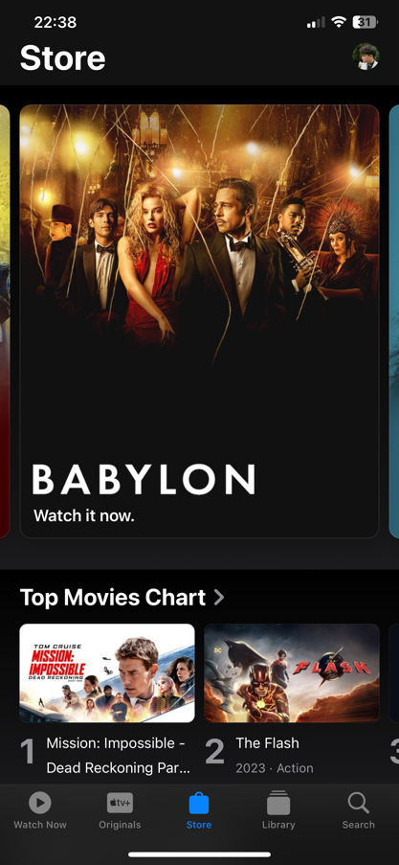

Figure 4 TV app

The movie app contains a large set of the movie. In order to attract the user, displaying movie poster with the title is the best choice. However, in the context of mobile app, the space is limited. If we want to show case all the poster of the current best movies, the image carousel is the best choice to show it.

**Advantage:**

The image carousel is efficiency for saving the space. This will be archive by in a certain space, they allow multiple image and content pieces can be displayed. For this apple TV app, this picture carousel makes them ideally for showing the famous tv by their poster appear as a image carousel. Meanwhile, they can encourage user interaction and engagement by allowing user to navigate through the carousel, providing a sense of control over the displayed content. Also, they make the overall design more visually appearing.

**Disadvantage**

The user may not see all the content of the picture within the

carousel which if they rotate too quick. As the app provide above, they have counter it by letting the user rotate it on their own. Meanwhile, if the picture carousel only has simple picture, the user seem to ignore it and quicky scrolling pass them. For the application that I present above, on each image carousel, they have the title on each, make it more engaging as let the user know the name of the movie that the poster displays on the carousel seem attractive to them.

**UX design analysis:**

1. **Content structuring:**

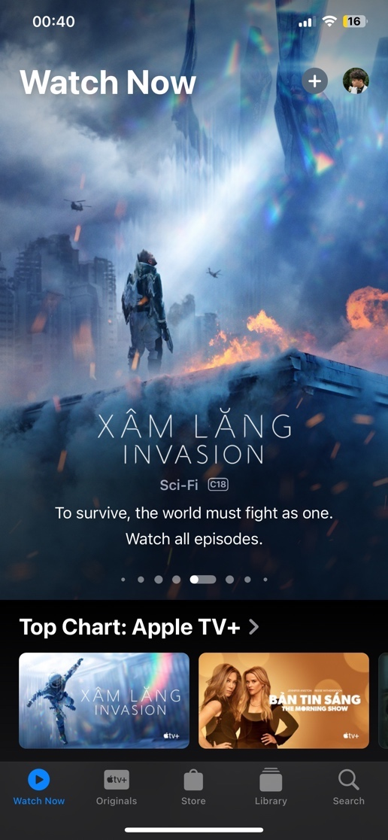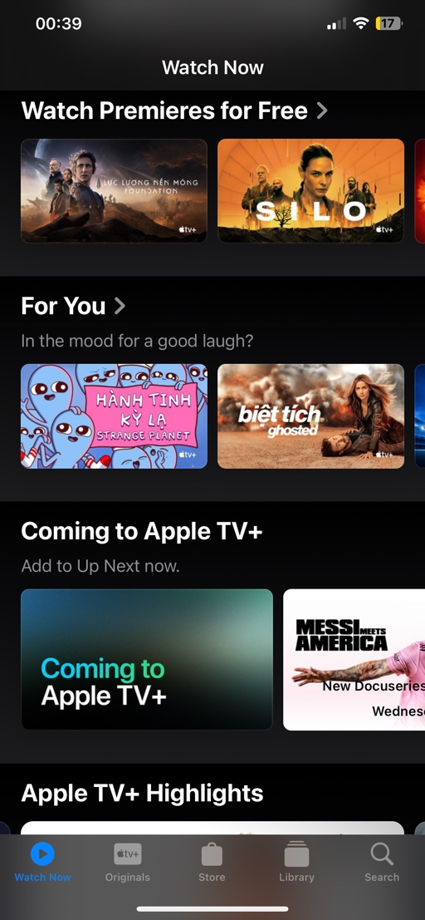

Figure 5 Content structuring in TV app

The content structuring on this app is good, they structure in a way will a big image carousel in the beginning, which will catch the user attention. Meanwhile, the other information, which not really require attention will be listed as different sector. Inside these sectors, the user can navigate though the movie with the card carousel. A gradient of black colour is applied to separate the sector, which is a really good design. Everything’s remains as simple as it can which make the user feel comfortable with the ease of use.

1. **Incentivization:**

For incentivization, if the user takes a quick look though the apps, they will only be attract of the movie poster. These image are clickable but for the new user, they will not realize it for the first time and will skip it. This app is not a good practice at incentivization UX design.

# Navigation tabs

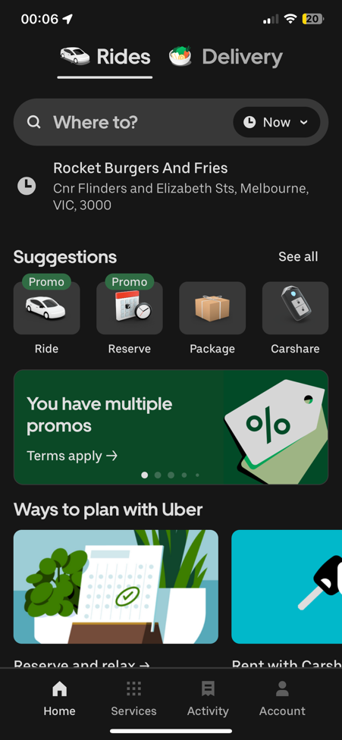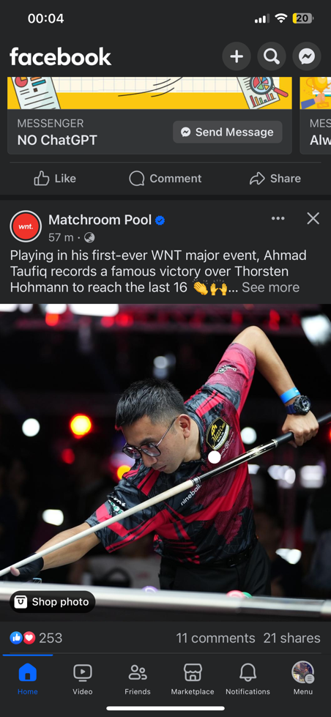

Figure 6 Navigation tabs in Uber and Facebook app

In the example app above, both apps contain different page. For those pages with different information, the navigation tabs need to be used. For modern days app they contain lots of different section which will provide for the user various of information. The navigation tabs is the best practice to implement on these app.

**Advantage**

The navigation tab UI design pattern can provide a clear way and organized to present different section or categories of content that make it easier for the user to locate and access specific information. These navigation tabs will provide a consistent way for the user to navigate through different section of the application or website, enhancing usability.

**Disadvantage**

If the tab has lots of component, the user may have difficult to press on the certain target. This might lead to a scalabilities issue of the navigation tab which the mobile phone with small display cannot contain large number of tabs.

For example, the navigation bar on Facebook. The navigation bar is contained 6 components for different navigation. This could lead to difficulties for the user that have the problem with eyes cannot be easy to press it, such as the old people. Meanwhile the navigation tab in the uber app is remain simple which could.

**UX design:**

1. **Hierarchy:**

For the uber app, the main hierarchy focus on the process of selecting a ride. The screen will appear a section with a different option for different types of ride, with clear visual cues and labels to guide the user.

For the Facebook app, the hierarchical UX design is prominently visible in the news feed, where posts from friends, pages, and groups are organized based on relevance and user interaction. It will prioritize content based on factors such as user engagement, post popularity, and relationship closeness.

1. **Incentivization:**

For the Uber app, we can see clearly the incentivisation in the suggestion section the app will give the user the promotion for the ride. Meanwhile, they also recommend to the user that they can use uber ride to send the package, which encourage the user to take an uber for various of purpose.

Through the use of tools like likes, comments, and shares, Facebook has added social validation to incentivize users to interact more with the posts made by their friends, pages, or groups.

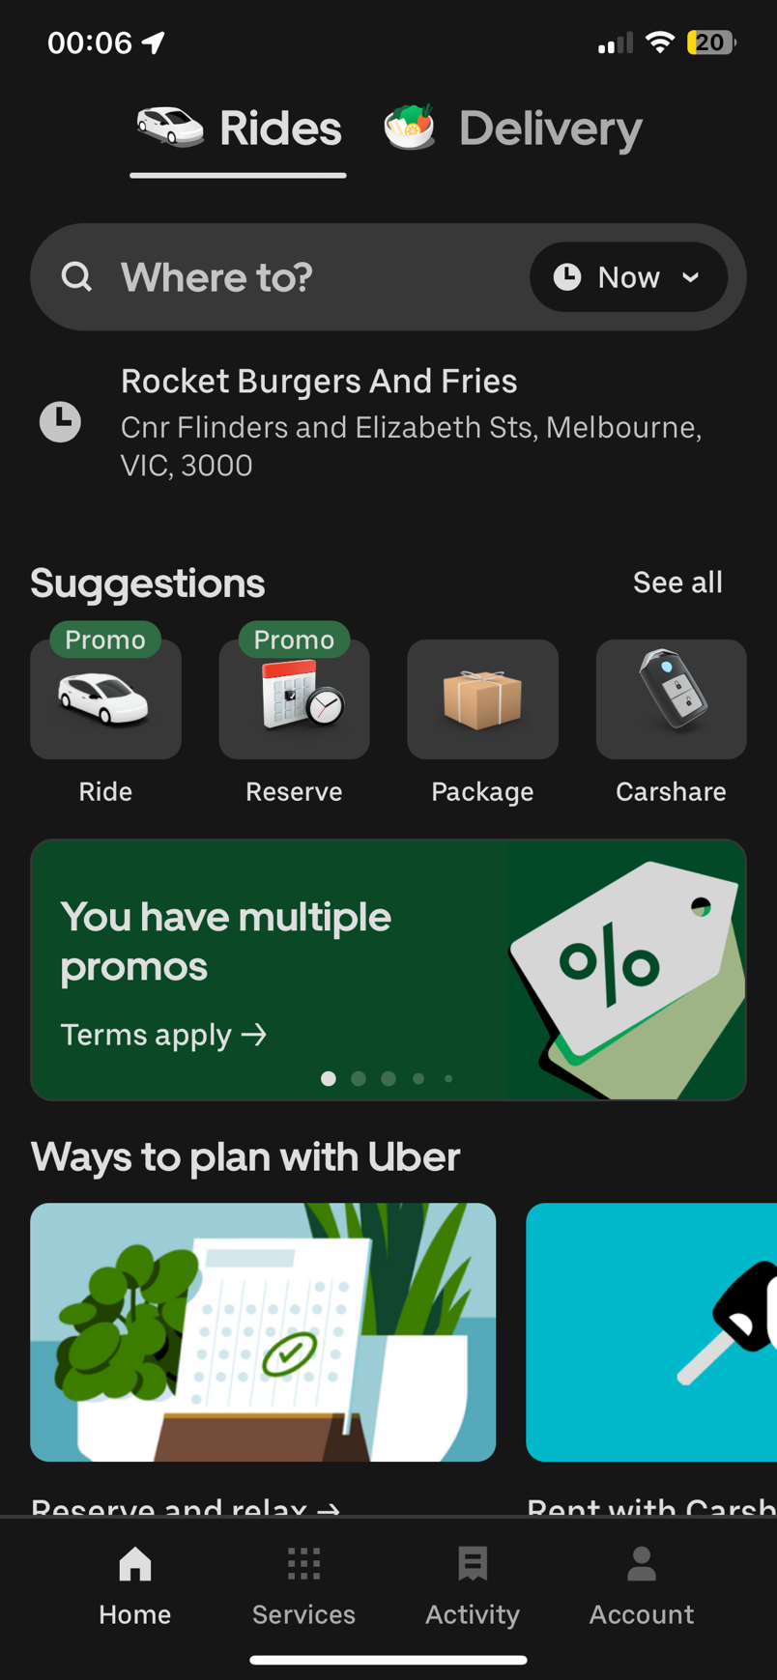

Figure 7 Promotion on Uber app

# References

*Cards design pattern*. (n.d.). Ui-Patterns.com. https://ui-patterns.com/patterns/cards

*Carousel design pattern*. (n.d.). Ui-Patterns.com. https://ui-patterns.com/patterns/Carousel

*Navigation Tabs design pattern*. (n.d.). Ui-Patterns.com.

https://uipatterns.com/patterns/NavigationTabs

*UX Design Patterns You Should Focus On*. (2021, January 28). Studio by UXPin. https://www.uxpin.com/studio/blog/ux-design-patterns-focus-on/

‌